for loop
___________________________________________________________________
For loop is same like as while loop with some major syntactical difference

Syntax: for( initialization; condition ; increment or decrement)
{
write here your logics
}

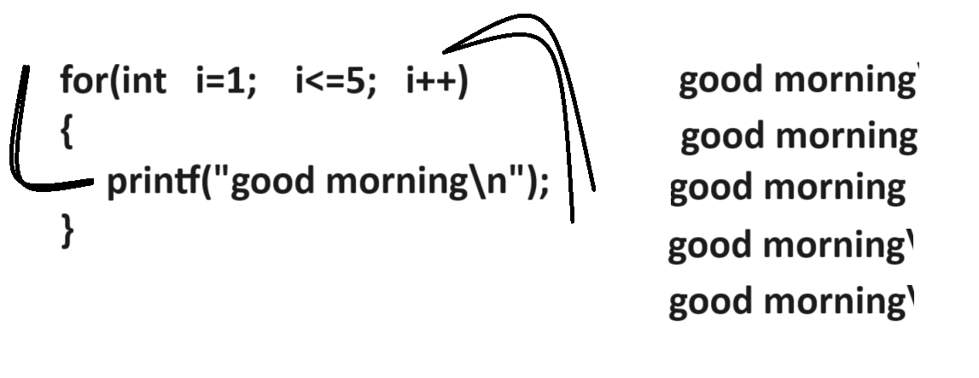
Example:
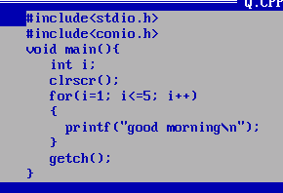
You can manage for loop by using a different ways
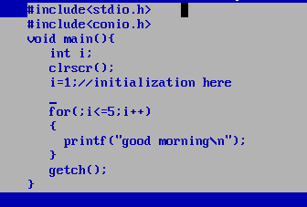
or you can write for loop like as
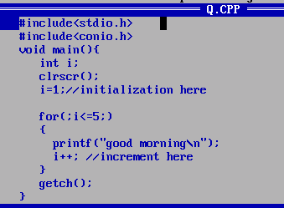
or
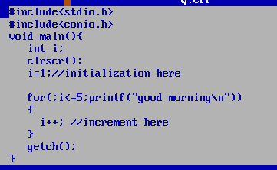
or

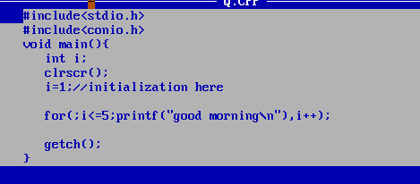

Example: WAP to input number and reverse it using for loop
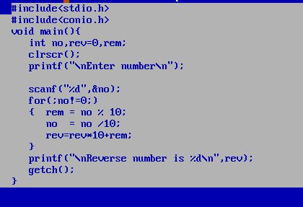

Nested for loop
________________________________________________________________
Nested for loop means for within for called as nested for loop.
Nested for loop specially design for work with matrix here our for loop work as row and inner for loop work as column

Syntax:
for(initialization; condition; increment or decrement) //outer loop or row
{
for(initialization ; condition; increment or decrement) //inner loop or column
{
write here your logics
}
}
Note: if we think about nested loop if outer loop execute only once then inner loop execute all times

Example:
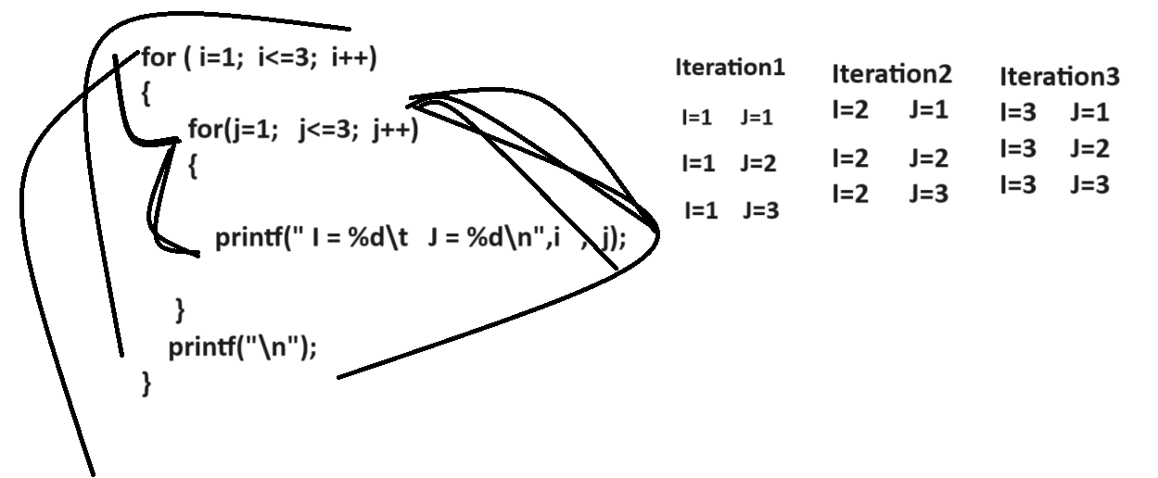

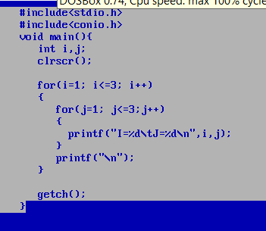
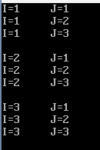

Example: WAP to display all tables between 2 to 10.
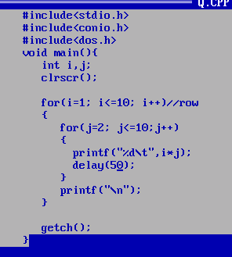

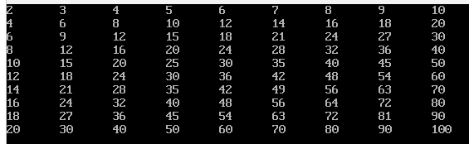

Example: WAP to print the following pattern
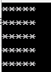
Source code
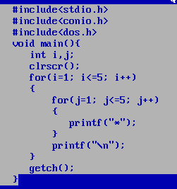
Example: Print the following pattern?
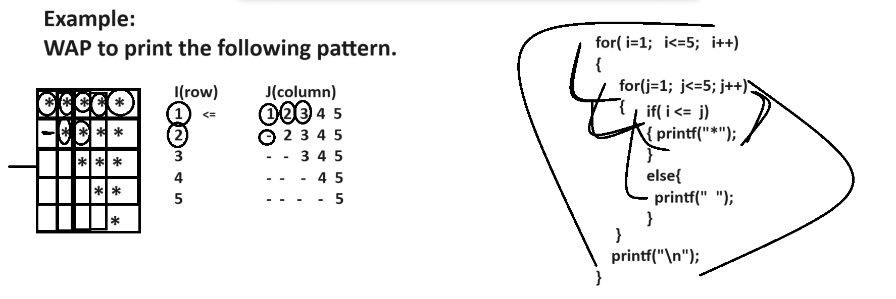

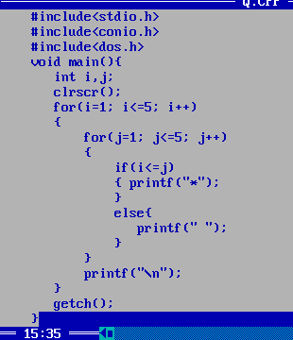
Q. WAP to print the following pattern?
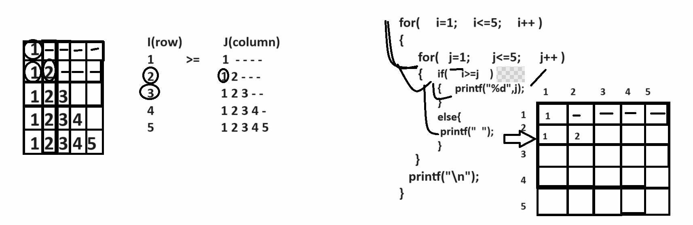

Q. WAP to print the following pattern?
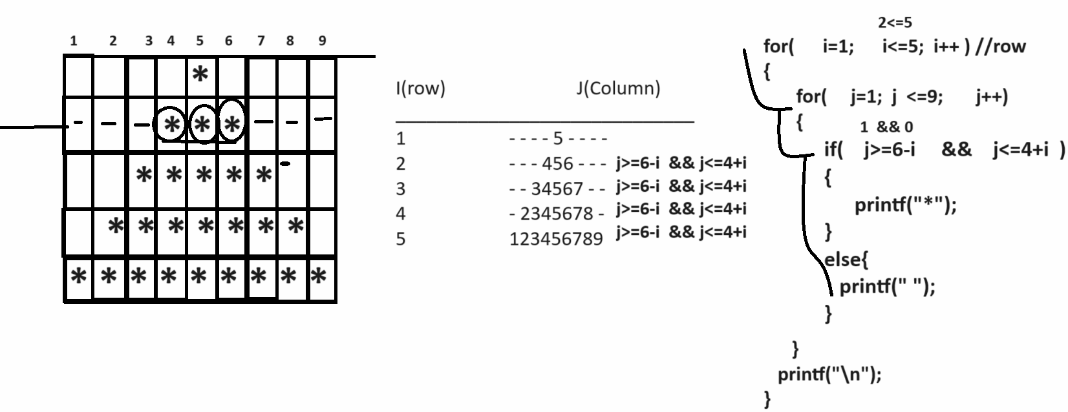

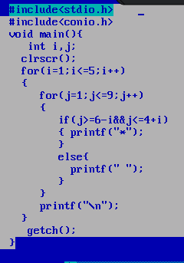

Example: WAP to print the following pattern?

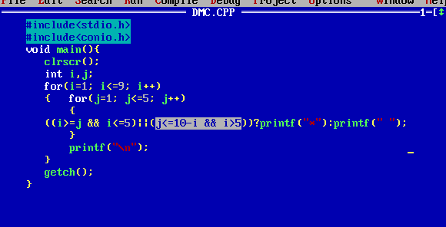

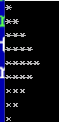

Q. WAP to print the following pattern?
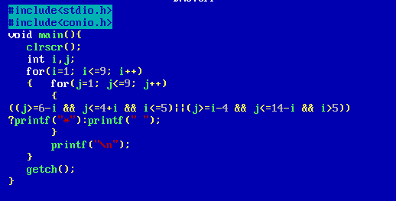
Output
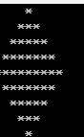
Example: WAP to print the following pattern?
